The WONCA Waynakay Movement is born
WONCA News August 2010
At the 19th World Organization of Family Doctors conference (WONCA Cancun 2010), preconference meetings were conducted on the 18th and 19th May, in conjunction with resident doctors and young family physicians (graduates of less than 5 years) from the Vasco da Gama Movement of Europe and the Asia Pacific Rajakumar Movement, where we could share experiences, ideas, information and advice on everything. This brought together over 100 residents and young family physicians from over 20 countries around the world, with over 70% of Iberoamericana countries represented.
After the preconference and conference meetings, those resident in the Iberoamericana region decided on the formation of the Movement Waynakay. "Waynakay" means "youth" in the Quechua language, native to the Andes in western South America.
The aim is to form a group of medical residents and young family physicians (graduates of less than 5 years) in order to be able to carry out research, continuing education, and partial rotations abroad, to share information in order to strengthen family medicine from our training as specialists and strengthen family medicine in the region of Latin America.
The Executive of the Movement Waynakay is:
- President: Bruno Benevides Souza (Brazil)
- Vice President: Essie Hood Woodfin Maduro (Panama),
- Secretary: Maria Alejandra Sequeira Neme (Argentina)
- Treasurer: Andrea De Angulo Losada (Colombia)
- Honorary President Miguel Angel Quijada Fragoso (Mexico)
It also has a Board comprised of one representative from each country Edgar Uriel (Mexico), Sonia Kang (Paraguay), Bruno Benavides (Brazil), María Alejandra Sequeira (Argentina), Andrea De Angulo (Colombia), Carlos Hernández (El Salvador), Xavier Maldonado (Ecuador), Essie Maduro (Panama) y José Rafael Hernández (Venezuela).
There are technical committees such as: Communication Committee headed by Dr Evelyn Herverth Garcia (Mexico), Exchange Committee led by Dr Claudio Bullen Aguilar (Mexico) and the Education Committee by Dr Jorge Lopez Leal (Mexico).
From the editor: text thanks to Miguel Ángel Quijada Fragoso
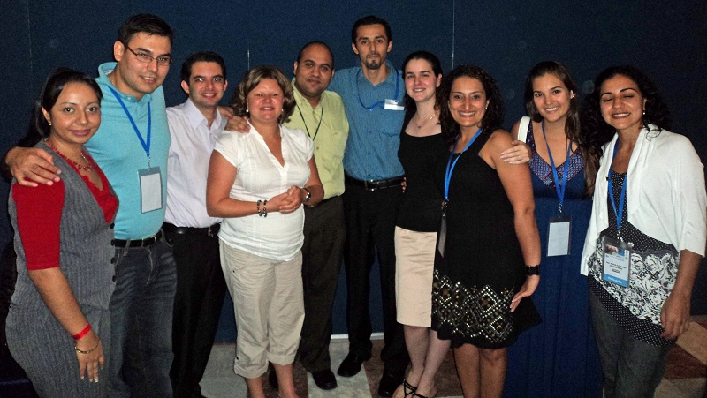

The Waynakay Movement is born (from l to r)
Evelyn Herverth García (México); Edgar Uriel Robles Salgado (México), Bruno Benavides (Brasil) Andrea Poppelier (Francia), José Rafael Hernández Jurado (Venezuela), Miguel Ángel Quijada Fragoso (México), Essie Maduro (Panamá), Lidia Amino (Suecia), Andrea de Angulo (Colombia), María Alejandra Sequeiro Neme (Argentina)

